



PYTHON PROGRAMMING
(355)

STATE 2024

APPLICATION KNOWLEDGE:
Python (460 points)

TOTAL POINTS (460 points)

Test Time: 90 minutes
StatePython

In this test you will be creating a file reading program for a pizza restaurant to be used in conjunction with its store operations software that could be tied to all of its other software systems for the company. The program you will create has one goal: read the txt file immediately to create the different types of pizzas and store those objects in a central object.
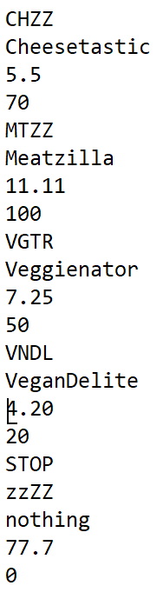
Input
The only input into the program will be the reading of the txt file. There is no user input. An example of the input from the txt file is provided to the left

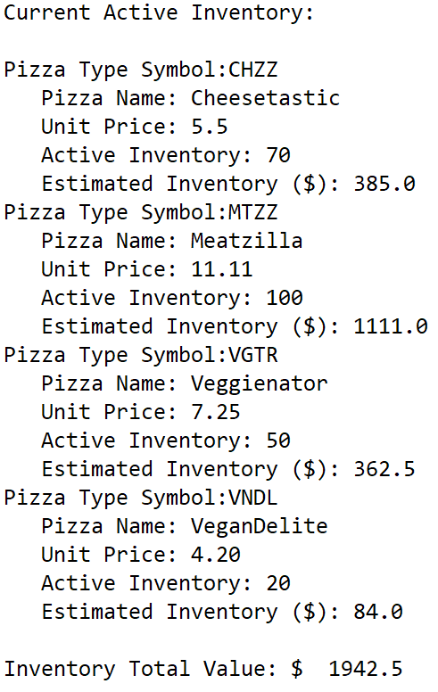
Output
The output from the code will be a single print job to the console. An example of the exact output from your program is provided (see the image to the right). You are required to create this print format in the Pizzas.py file. Your job will be to read the file and get the proper values for the record into the correct order and to get the output to print to console where the pattern uses a hanging indent to separate the records for readability.

Missing File Error
If the file is missing from the folder, output from the code should print the OS error message and the error object, following by printing the exit object, and exit the program.

Your application will be graded on the following criteria:
Solution and Project
The project is present on the flash drive ____ 20 pts
The four required files are all in one folder ____ 10 pts
Program Execution
The PizzaOrderController class runs and reads the input file ____ 30 pts
If the program does not execute, then the remaining items in this section receive a score of zero.
Program displays the OS error err object message if the file cannot be found ____ 20 pts
Program displays the exit command message and exit the program if the file
cannot be found ____ 20 pts
Output format matches sample ____ 30 pts
The program quits reading from the text file at the word “STOP” from
txt file and does not print extra symbols ____ 30 pts
Estimated Inventory value matches the output for each item (no partial credit) ____ 30 pts
Inventory Total Value matches the desired output ____ 30 pts

Subtotal______/210

Source Code Review
NOTE: you must place the comment flag in front of the comment in your code in order to get credit. The comment flag will precede the explanation. For example, if the flag is SC1, your comment must read as “#SC1…” in front of the part of the code being reviewed. Code must work to get credit.
SC1: PizzaOrderController imported proper class to construct correct object ____ 10 pts
SC2: PizzaOrderController constructs the PizzaMenu object ____ 10 pts
SC3: PizzaOrderController code to read the txt file line by line with
proper variable assignment ____ 20 pts
SC4: PizzaOrderController uses try/except to catch missing file and prints
the exception object message ____ 30 pts
SC5: PizzaOrderController prints out the exit command message and exits ____ 20 pts
SC6: PizzaMenu constructor with data structure attribute ____ 10 pts
SC7: PizzaMenu method createPizza creates Pizzas objects and adds
to data structure designed to hold Pizzas objects ____ 20 pts
SC8: PizzaMenu method getInventoryTVL gets the sum of all the
Estimated Inventory values of the pizza objects ____ 20 pts
SC9: PizzaMenu method __str__ gets the all the string output of the
pizza objects by using their printPizzaType method ____ 20 pts
SC10: PizzaMenu method __str__ prints the total value of inventory ____ 20 pts
SC11: PizzaMenu method __str__ returns the complete output of the list ____ 20 pts
SC12: Pizzas constructor assigns proper values to instance variables ____ 10 pts
SC13: Pizzas method __str__ completes output of the object and returns ____ 20 pts
SC14: Pizzas method getValue calculates and returns the inventory value ____ 10 pts
SC15: Pizzas method printPizzaType calls the __str__ method and returns
the proper output for the current inventory. ____ 10 pts
Subtotal______/250

Total Points: _______/ 460pts

2 #SC1
3 import PizzaMenu
4
5 class PizzaOrderController:
6 #STUDENT_POINT
7 pizza1 = PizzaMenu.PizzaMenu() #SC2
8 #STUDENT_POINT
9 try: #SC4
10 with open("PizzasText.txt") as f:
11 pizzaSymbol = f.readline() #SC3
12 while (pizzaSymbol.upper().strip()!="STOP"): #SC3
13 pizzaName = f.readline() #SC3
14 pizzaPrice = f.readline()#SC3
15 stockVolume = f.readline()#SC3
16
17 pizza1.createPizza(pizzaSymbol, pizzaName, pizzaPrice, stockVolume)
18 pizzaSymbol = f.readline()
19 except OSError as err: #SC4 #STUDENT_POINT
20 print("OS error:", err)
21 print(exit) #SC5 #STUDENT_POINT
22 exit()
23 #GIVEN
24 print(pizza1)

-----------------------------------------------------------
1 import Pizzas
2 #STUDENT_POINT
3 class PizzaMenu:
4 def __init__(self): #SC6
5 self.pizza = []
6 self.size = 0
7 #STUDENT_POINT
8 def createPizza(self, sym, nam, pri, sha): #SC7
9 temp = Pizzas.Pizzas(sym, nam, pri, sha)
10 self.pizza.append(temp)
11 self.size += 1
12 #STUDENT_POINT
13 def getInventoryTVL(self): #SC8
14 tempValue = 0
15 for s in self.pizza:
16 tempValue += float(s.getValue())
17
18 return tempValue
19 #STUDENT_POINT
20 def __str__(self): #SC9
21 portfolioPrinter = ""
22 tempCount = 0
23 while(tempCount < self.size):
24 portfolioPrinter = portfolioPrinter + str(self.pizza[tempCount].printPizzaType()) + "\n" #SC10
25 tempCount += 1
26
27 self.stringValue = str(self.getInventoryTVL())
28 return f"Current Active Inventory:\n\n{portfolioPrinter} \nInventory Total Value: $ {self.stringValue}" #SC11

-----------------------------------------------------------
1 class Pizzas:
2 unitPrice = 0.0
3 inventoryCount = 0
4 pizzaSymbol = ""
5 pizzaName = ""
6
7 #STUDENT_POINT
8 def __init__(self, pizzaSymbol, pizzaName, unitPrice, inventoryCount): #SC12
9 self.pizzaSymbol = pizzaSymbol
10 self.pizzaName = pizzaName
11 self.unitPrice = unitPrice
12 self.inventoryCount = inventoryCount
13
14 #STUDENT_POINT
15 def getValue(self): #SC14
16 return (float(self.unitPrice) * int(self.inventoryCount))
17
18 #STUDENT_POINT
19 def __str__(self): #SC13
20 return f"Pizza Type Symbol:{self.pizzaSymbol}\tPizza Name: {self.pizzaName}\tUnit Price: {self.unitPrice}\tActive Inventory: {self.inventoryCount}\tEstimated Inventory ($): {self.getValue()}"
21
22 #STUDENT_POINT
23 def printPizzaType(self): #SC15
24 return self.__str__()
25

